22nd Sunday in Ordinary Time
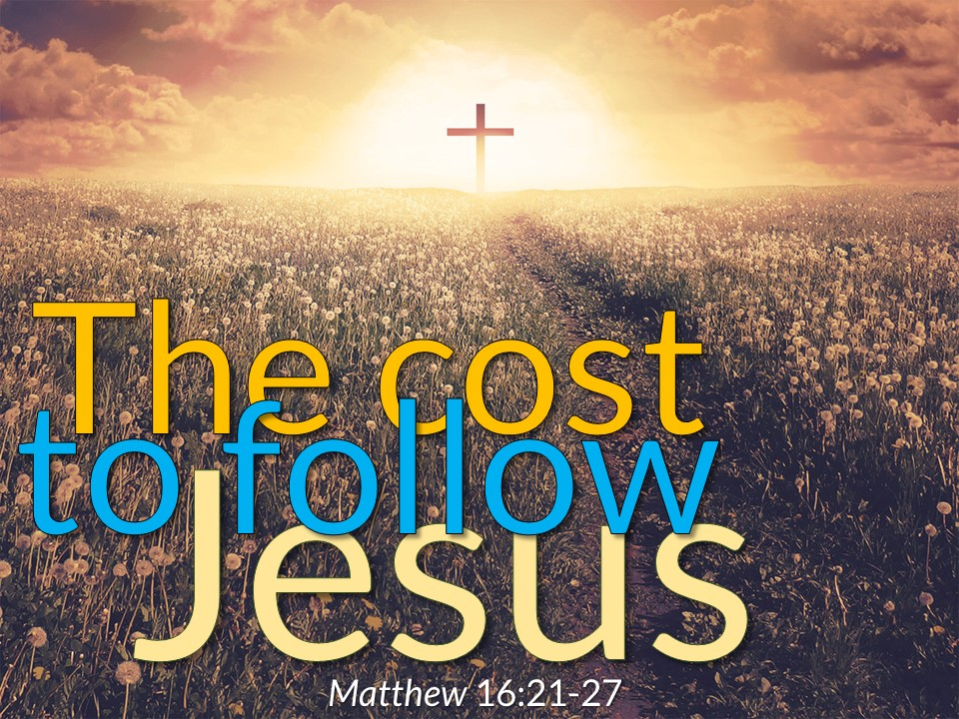

1st Reading: Jeremiah 20:7-9
Jeremiah complains to God at having to preach such an unwelcome message
O Lord, you have enticed me, and I was enticed; you have overpowered me, and you have prevailed. I have become a laughingstock all day long; everyone mocks me. For whenever I speak, I must cry out, I must shout, “Violence and destruction!” For the word of the Lord has become for me a reproach and derision all day long. If I say, “I will not mention him, or speak any more in his name,” then within me there is something like a burning fire shut up in my bones; I am weary with holding it in, and I cannot.
Responsorial: Psalm 62:2-6, 8-9
Response: My soul is thirsting for you, O Lord my God
O God, you are my God, for you I long;
for you my soul is thirsting.
My body pines for you
like a dry, weary land without water. Resp:
So I gaze on you in the sanctuary
to see your strength and your glory.
For your love is better than life,
my lips will speak your praise. Resp:
So I will bless you all my life,
in your name I will lift up my hands.
My soul shall be filled as with a banquet,
my mouth shall praise you with joy. Resp:
For you have been my help;
in the shadow of your wings I rejoice.
My soul clings to you;
your right hand holds me fast. Resp:

2nd Reading: Romans 12:1-2
St Paul’s intention in this letter:
Do not follow the social conventions of this world, but try to discern what is the will of God.

I appeal to you therefore, brothers and sisters, by the mercies of God, to present your bodies as a living sacrifice, holy and acceptable to God, which is your spiritual worship. Do not be conformed to this world, but be transformed by the renewing of your minds, so that you may discern what is the will of God-what is good and acceptable and perfect.

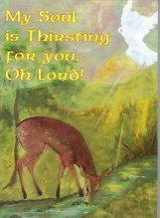
Gospel Acclamation:
Alleluia, Alleluia!
May the Father of our Lord Jesus Christ
enlighten the eyes of our heart,
that we might see how great is the hope
to which we are called.
Alleluia!

Gospel: Matthew 16:21-27
The disciple of Jesus must also follow the way of suffering and self-renunciation
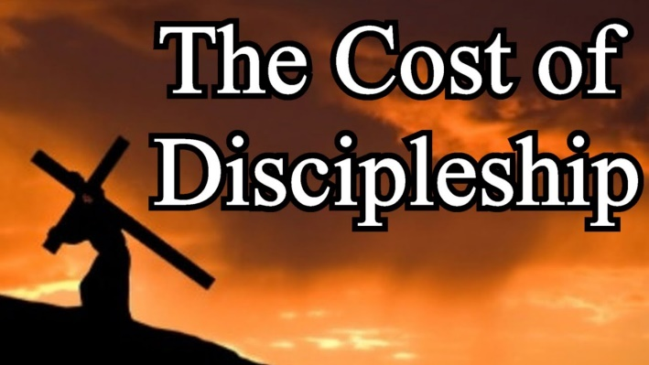
Jesus began to show his disciples that he must go to Jerusalem and undergo great suffering at the hands of the elders and chief priests and scribes, and be killed, and on the third day be raised. And Peter took him aside and began to rebuke him, saying, “God forbid it, Lord! This must never happen to you. ” But he turned and said to Peter, “Get behind me, Satan! You are a stumbling block to me; for you are setting your mind not on divine things but on human things.” Then Jesus told his disciples, “If any want to become my followers, let them deny themselves and take up their cross and follow me. For those who want to save their life will lose it, and those who lose their life for my sake will find it. For what will it profit them if they gain the whole world but forfeit their life? Or what will they give in return for their life? “For the Son of Man is to come with his angels in the glory of his Father, and then he will repay everyone for what has been done.

Reflections
If invited to pick and choose within the Gospels, and form our religion only with what appeals to us, what a cosy, comfortable church we would have! We might keep the stories about Christ’s birth and infancy, his temptation in the desert and his healing miracles. We would include our favourite parables, like the Prodigal son, the Pharisee and the Publican, and of course, the Good Samaritan. But would we leave out that Gospel for today, that hard teaching about renouncing self, taking up the cross, losing our lives for the sake of Jesus? And even if we have not removed those words from our Gospels, do we remain deaf to them in practise, in our lives?
In a way, isn’t following Christ like accepting a friend whom we must accept in full or not at all; welcoming the demands as well as the benefits of friendship? Just as we need to take people as they are, without trying to change them to suit ourselves, so with the Gospel: we accept the whole of Christ’s recorded words, because we trust him and know that his ways are truth.
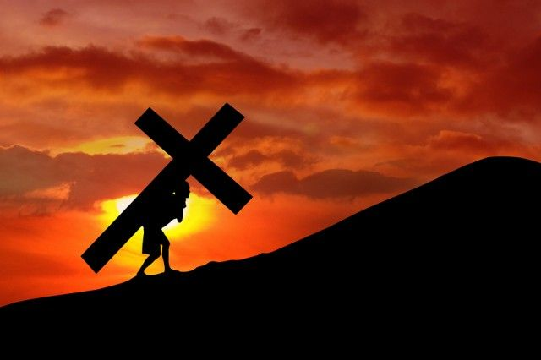
So what does the Lord want from us? What does he mean by “renounce yourself,” “lose your life for my sake,” “carry your cross,” or (in the epistle) “present your bodies as a holy sacrifice?” Surely these words don’t refer to anything suicidal, to devaluing of this present life, its joys and its achievements? And yet, are these not something more than a pious way of saying: Put up with what cannot be changed? These are questions to revolve in the mind, without expecting any quick or simple solution. If we will allow, God’s Word challenges us out of any complacency with a comfortable, conforming religion. It unmasks our many evasions, our double standards, our desire for “cheap grace” — wanting salvation at cut price, unwilling to involve ourselves in sacrifice.
Perhaps a clue to this demand is in the first reading, in Jeremiah’s extraordinary accusation that he was seduced by God. Letting his prophetic vocation overpower him, Jeremiah was involved in many a thankless task. He had fallen in love with God, so that nothing held him back from doing God’s will, no matter where this might lead. Have we fallen in love with Christ? Are we seduced by him, so as to give to his service all that is ours to give? Wouldn’t that be becoming a living sacrifice?
We might overly focus on the “renunciation” in today’s Gospel so as to miss its positive aspect. All growth, all lasting achievement demands effort and sacrifice. Yet the sacrifice can be a satisfying part of experience, when orientated towards a high and valued goal. (Examples: athletic training; mountain-climbing; studying a language; practising any skill.) So, the self discipline involved in Christian life, and accepting the circumstances in which God places us, contribute to our personal destiny. And we look forward in hope to the great reward of loyal service — when the Son of man, coming in glory, will reward all according to their behaviour.

